

Code of
Business Ethics
Smiths Detection

A note from Jerome de Chassey
Chief Executive Officer, Smiths Detection
Dear colleagues,
Our company has been built on a foundation of doing business the right way. That is why we are trusted by colleagues, customers, suppliers, investors and other stakeholders. Protecting and nurturing that trust is key to our continued success.
Having an ethical culture – treating people fairly and being transparent and accountable for business decisions – brings significant benefits to us all. It creates a positive work environment which helps us attract, retain and motivate our staff. And our customers want to deal with partners they can rely on.
Smiths Detection is such a partner. For us, acting with integrity is not a choice. It's who we are.
How can we tell if something isn't ethical? The reality is that what is right and wrong isn't always crystal clear – there are grey areas. But we all know when something doesn't feel right. Our Code of Business Ethics is here to help us navigate ethical decision-making. It identifies lines that mustn't be crossed, red flags which need to be carefully reviewed, and resources to help us come to the right decision. While it won't have all the answers, it is a good starting point and important for us all to know and understand. It is everyone's responsibility to make sure they are familiar with the Smiths Detection Code of Business Ethics.
What if you experience behaviour or activities that don't align with our Code? Perhaps you're put under pressure to do something you feel isn't right. Or you experience a colleague being treated unfairly. Maybe you've discovered activity that appears unethical or even illegal. If this is ever the case, the most important thing to remember is that you're not on your own. You can turn to your line manager, local HR representative, or your senior local or global management. And if for whatever reason you feel uncomfortable doing any of these, remember that our Ethics Portal is always here for that very purpose. Anyone who comes forward with an ethics concern will be supported by Smiths Detection's leadership.
Smiths Detection has a bright and exciting future ahead and I am grateful to every one of you for the part you will play. Together, we will continue to drive our business forward in the right way.
Thank you,
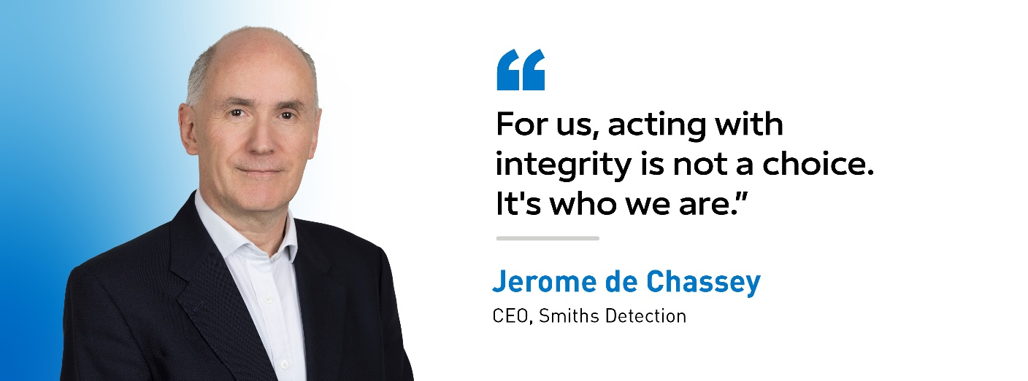
Table of Contents
We Do The Right Thing 4
We Respect Each Other 8
We Take Responsibility 10
We Earn Customer Trust 11
We Are United In Purpose 12
The Ethics Portal 13



WE DO THE RIGHT THING
We comply with all laws where we operate.
We act within applicable laws and rules and hold our business partners accountable to the same.¹
¹ Example:
The purchasing agent for the airport has contacted Tom and told him that Smiths Detection will win the bid if he can provide the purchasing agent with a payment of 3% of the total contract.
What should Tom do?
Tom should not make the payment, and he should immediately inform his manager. Smiths Detection does not provide bribes, kickbacks or agree to participate in any bid rigging or other anticompetitive activity. We win through the quality and value of our products and services, and by using fair bidding and business practices.

We stand firmly against bribery and corruption.
We never offer or accept bribes, kickbacks, or any other kind of improper payment, including facilitation payments. We only appoint third party representatives (including distributors or agents) who we trust will follow this rule.
We keep accurate books, records, and data.
We record transactions honestly so that company funds are not used unlawfully. We provide our stakeholders with up-to-date, accurate and complete information in a timely manner. We never commit fraud. We never manipulate data.
We protect Smiths Detection assets.
We act with vigilance to protect Smiths Detection assets from damage, misuse, fraud, and cyberattacks.
We get approval before engaging in any political or charitable activities for Smiths Detection.
We obtain necessary approvals before engaging in any lobbying activities, and when appropriate, we make clear that personal views are not those of Smiths Detection.*
*In the US, Smiths Detection operates a political action committee through which colleagues voluntarily contribute funds to politicians who advocate for causes in line with Smiths Detection’s business interests.
We follow international trade laws.
We comply with all applicable trade laws – export and import controls, economic sanctions, anti-boycott rules, regulations, policies and procedures – in the countries where we operate or buy, sell or transfer products, services, technology or software.
We never give or receive improper gifts, meals, or hospitality.
We ensure that such items are not lavish, comply with local laws, and are allowed by our policies and those of our customer or business partner.
We avoid, disclose, and manage conflicts of interest.²
We document and manage any conflict of interest. A “conflict of interest” is when your interests compromise (or appear to compromise) your ability to make an unbiased decision at Smiths Detection. Notify your line manager and HR in writing of any situations that create a conflict of interest or the appearance of one, or if you have any doubts.
² Example:
Yuki is responsible for buying supplies for her Smiths Detection office. Her brother owns a computer supply business. He offered to sell Yuki the equipment at a discount, and Yuki purchased it without disclosing their relationship to Human Resources.
Is Yuki acting properly?
No — We always disclose potential conflicts of interest. Yuki should notify Human Resources that her brother is the owner of the computer supply company before buying the equipment (even if her brother is providing the best price and service). Human Resources may allow Yuki to purchase, but the decision will not be impacted by a potential conflict of interest.

We never engage in or assist others with money laundering or unlawful evasion of taxes.
We conduct due diligence on counterparties to assess legal and ethical risks, and we never engage in or assist others with illegal activity involving finances or tax.³
³ Example:
Ricardo received a call from a distributor who is angry that another competing distributor in the same territory is selling our products at a lower price. The distributor asked Ricardo to talk to the competing distributor, to ask them to raise their prices to match the others in the territory.
Should Ricardo do this?
No — We never seek to influence the price at which our distributors or any other reseller sells our products to end-users. This would likely violate the law and create serious consequences for Ricardo and for Smiths Detection. Ricardo should not agree. He should report the request to his manager and to Legal.

We compete fairly.
We do not collude with our competitors to fix prices, rig bids, allocate customers, or restrict supply, or engage in any other improper anticompetitive behavior.


WE RESPECT EACH OTHER
We celebrate diversity, equity, and inclusion.
We treat others with fairness and respect. We recognise that our success depends on the diverse perspectives, beliefs, and cultures that our people bring. We promote and maintain equal opportunity for all and make all employment-related decisions on merit. We never discriminate based on gender, race, ethnicity, sex, sexual orientation, disability, religion, age, cultural backgrounds, life experiences, thoughts, or ideas. We empower and advocate for others. We never harass anyone. We speak out if we see behaviour that is not fair, respectful, or inclusive.
We are compassionate.
We treat others with kindness. We do not tolerate any physical, verbal, or nonverbal forms of abuse or harassment. We support the mental wellbeing of colleagues with respect, understanding and by providing resources (such as the Employee Assistance Programme).
We protect human rights.
We respect and protect all human rights. We never tolerate inhumane treatment of anyone who works at Smiths Detection, and we report any suspected human rights abuses to the Ethics Portal. We select business partners carefully, conducting due diligence to ensure their principles align with ours. We respect the rights of employees to join or not join a trade union or similar organisation. We never employ or tolerate any form of forced labour or child labour or withhold identity documents of employees.
We safeguard privacy.
We respect and protect the personal data trusted to us by others. We collect personal data only for lawful and necessary purposes, act transparently in our use of data, store it securely, and delete it when it is no longer needed. Where personal data is transferred to a third-party provider, we verify that they maintain necessary controls to secure the data and ensure compliance with applicable local laws.
We respect Smiths Detection’s reputation.
We never comment publicly on behalf of Smiths Detection without obtaining appropriate approvals and complying with relevant policies.

WE TAKE RESPONSIBILITY
We keep ourselves and others safe.
Safety comes first – nothing is more important. We stop work when it is unsafe to continue. We know and follow safety protocols and emergency procedures, and we report any accident, injury, illness, or unsafe condition immediately. We follow Smiths Detection’s Safety Cardinal Behaviours and strive to be injury-free. We never work impaired (by alcohol, drugs, fatigue, injury, illness, or otherwise), and we speak out if we observe any unsafe behaviour or unhealthy work environment. We never tolerate threats or violence. We comply with all laws and regulations regarding restricted substances.
We care for our environment and the future of our planet and society.
We improve the world in meaningful ways. We commercialise technologies that will help transform industries and enhance safety. We use natural resources responsibly and work to reduce energy use and our greenhouse gas emissions to play our part in delivering global sustainability goals.. We have an unwavering commitment to strong governance and ethical practice.
We care about our communities and impact.
We strive to be a trusted neighbour, respecting local cultures and making a positive impact wherever we operate.
We continue to learn.
We continue developing ourselves and our business.

WE EARN CUSTOMER TRUST
We provide quality products and services.
We help solve the toughest problems for our customers and produce products with high quality standards. We communicate honestly with customers and provide products and services that meet or exceed their expectations. We never bypass processes. We never manipulate tests or data or take other improper actions that would break trust with our customers or business partners.
We commit to continuous improvement.
We embrace new technologies and methods. We strive for solutions to benefit both our customers and business.
We protect customer assets.
We protect intellectual property or proprietary information entrusted with us. We only share confidential information with those who need to know it to perform their jobs. We protect personal data of our customers and business partners, and only collect data when appropriate. We never disclose non-public information to any third party except as authorised. We take care of equipment provided by our customers.
We meet our commitments.
We honour our contracts and promises with our partners. We deliver results at pace.

WE ARE UNITED IN PURPOSE
We are united in purpose.
We are united by our purpose to make the world a safer place. We innovate for impact and hold ourselves accountable. We have a strong culture and team that works and stands together. It is what we do, why we do it and how we are charting our course to the future.
This is who we are.
We strive to be positive and punctual every day. We share thoughts and give feedback in constructive, helpful ways. We lead by example and inspire others. We focus on tasks and work with colleagues to overcome obstacles. Why? Because this is what it means to be Smiths Detection.


THE ETHICS PORTAL

What is the Ethics Portal?
The Ethics Portal is Smiths Detection's confidential channel for reporting serious concerns about potential wrongdoing. Hosted by Integrity Line, a secure and trusted third-party provider, the portal allows you to raise concerns about behaviour or activities that may be unethical or illegal. It is available to everyone, at any time, and is there for situations where you may not feel comfortable speaking to your line manager, HR representative or senior management. All reports made in good faith will be taken seriously and handled appropriately. You can access the Ethics Portal at www.smithsdetection.com/ethicsportal.

What happens after I submit a report?
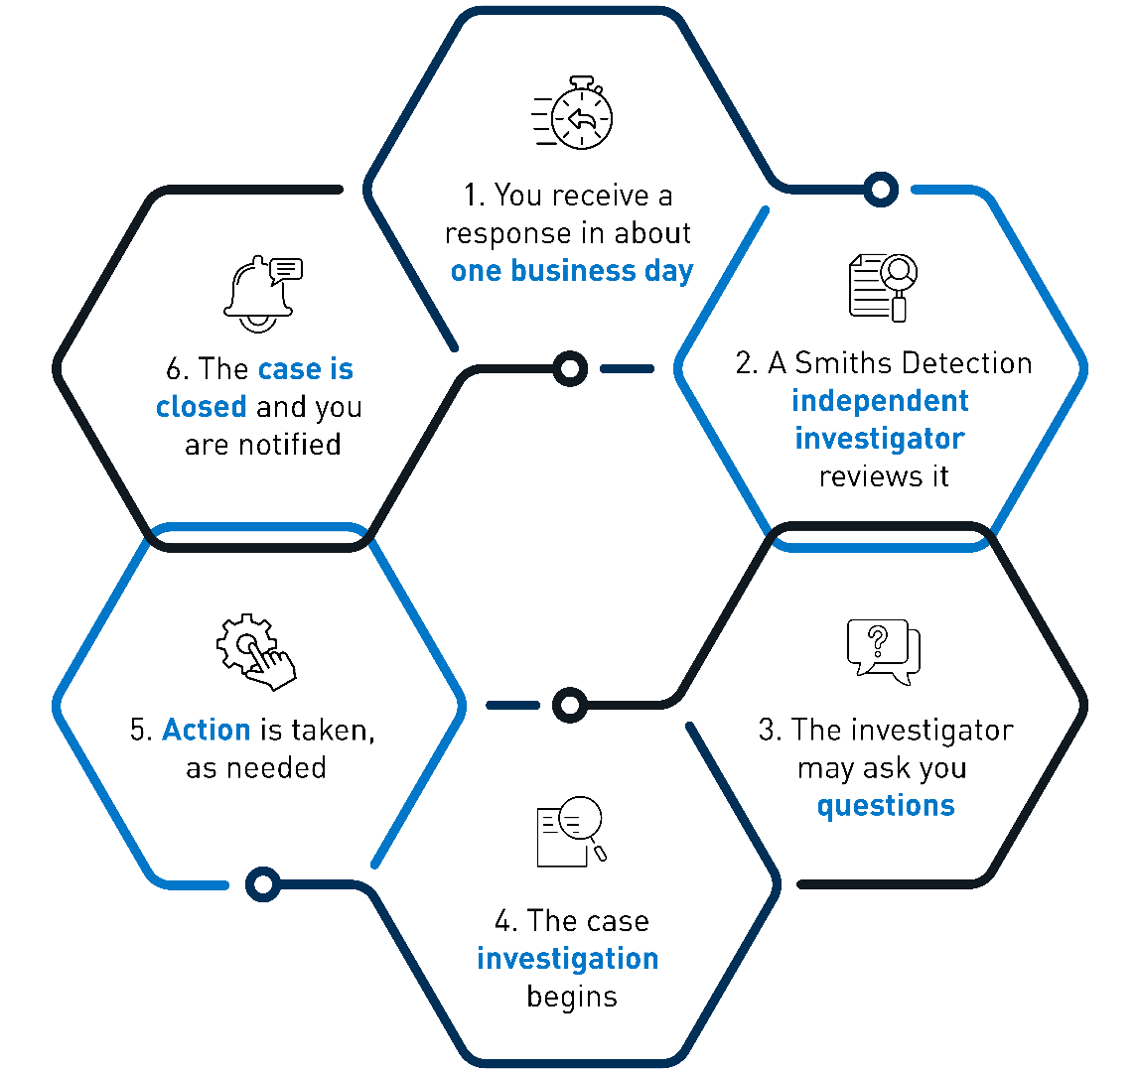

Is it safe to submit a report?
At Smiths Detection, everyone should feel safe and comfortable speaking out if they see something that violates our Code.
If you see something that violates our Code, you should notify your line manager or HR representative, or you can report through our Ethics Portal. As employees, we all play a vital role in the success of Smiths Detection. Operating with integrity is key. That’s why we each have a responsibility to report if we witness unethical behaviour within our business. It’s natural to feel hesitant or worry about reporting - but reporting is fully supported by Smiths Detection’s leadership. There are safeguards to protect you.

Confidentiality and Non-Retaliation
Your identity will always be protected. Only the Smiths Detection Ethics team investigators have access to reports submitted. The reports go into a highly confidential, password-protected third-party software system – not a Smiths Detection database. Reporters (whether internal or external) are protected from retaliation. Smiths Detection will not tolerate retaliation against any individual for reporting a good-faith concern or complaint or for participating in such an investigation. Strong action will be taken against anyone who attempts to retaliate, up to and including termination.

Can I report anonymously?
It’s your decision. You can report anonymously (subject to local laws). But our preference is that you share your identity because it helps the Ethics team investigate your concern faster, ask questions, and ensure you are comfortable with the process. However, Smiths Detection would always prefer you raise a concern anonymously than not at all.

HOW TO SUBMIT A REPORT


  - REPORT UNETHICAL BUSINESS BEHAVIOUR
At Smiths Detection, we take our values and reputation seriously. If any Smiths Detection employee, one of our businesses, or a business partner has done anything to breach the Supplier Code or our Code of Business Ethics – including any act of bribery, corruption, or other integrity concern – you have a responsibility to report it to Smiths Detection’s Ethics Portal.

Smiths Detection’s Ethics Portal is a web-based reporting service that submits your report directly to the Smiths Detection Ethics team. They review all concerns and conduct investigations as needed. Note that when you access the portal, you’ll be taken to a secure site hosted by Integrity Line, our trusted third party provider.
